[N3_L1_E1](https://github.com/jaidernperez/Introduction_Programing/blob/master/CodeGym/N3_L1_E1.PNG)

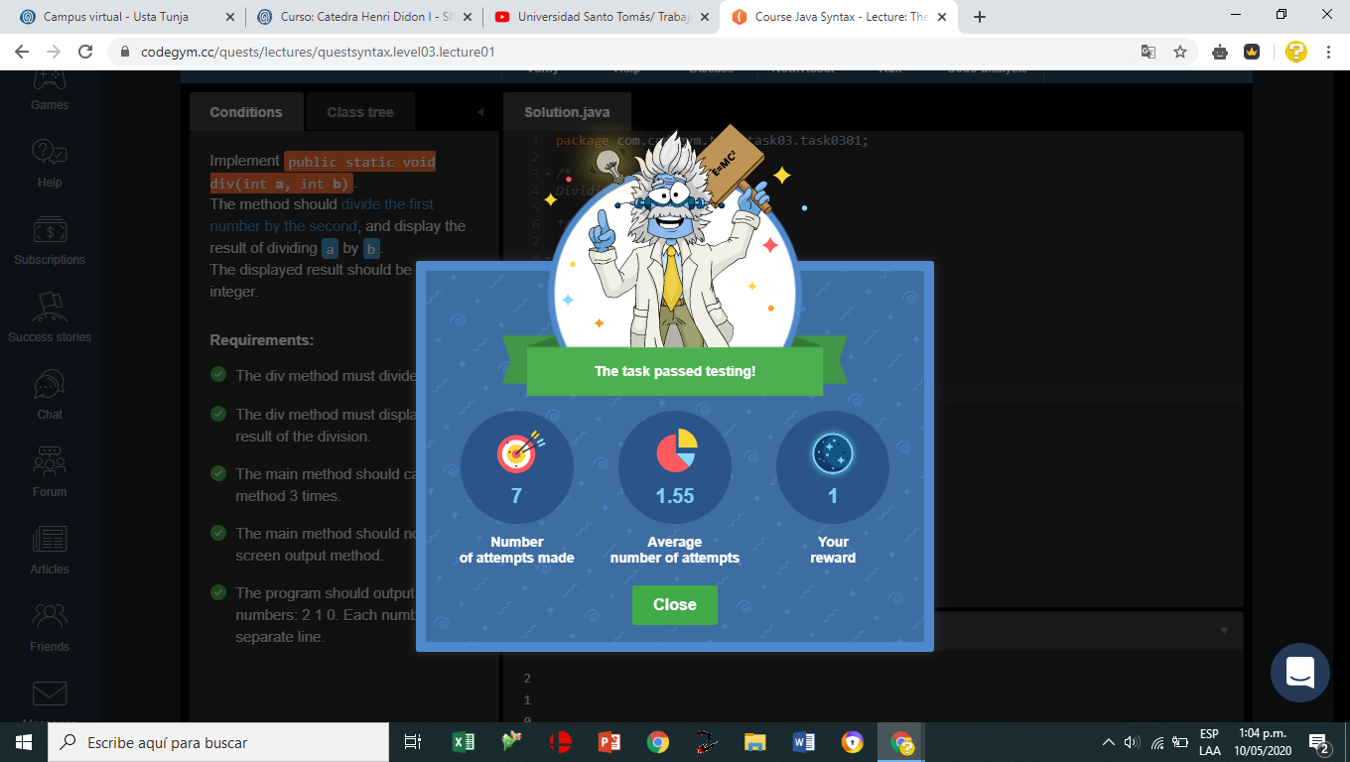

[N3_L3_E1](https://github.com/jaidernperez/Introduction_Programing/blob/master/CodeGym/N3_L3_E1.PNG)

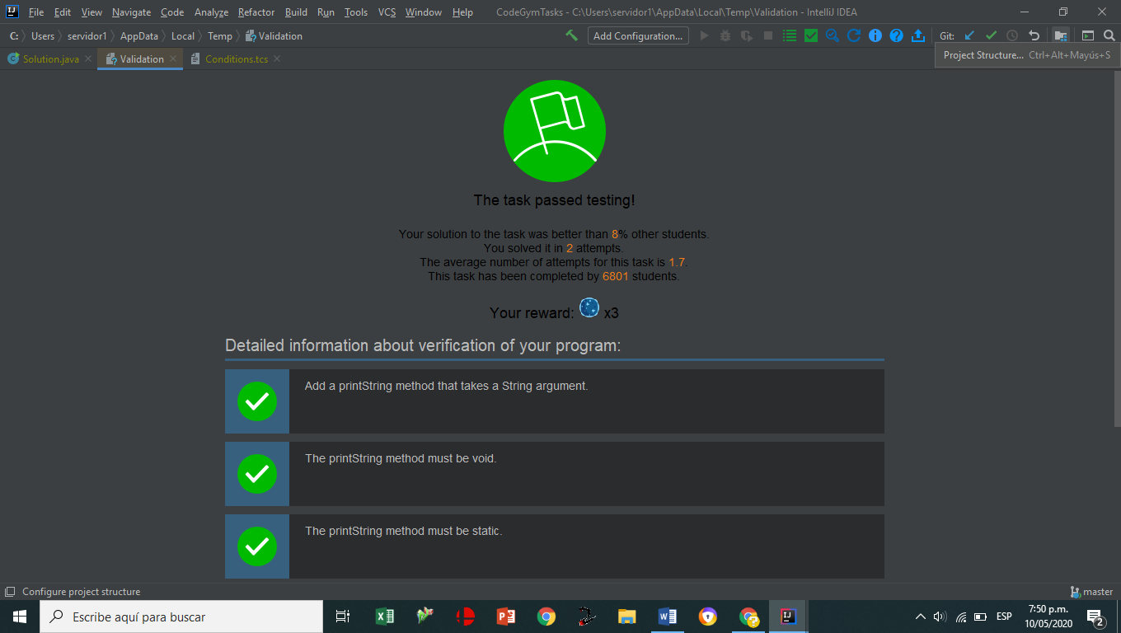

[N3_L3_E2](https://github.com/jaidernperez/Introduction_Programing/blob/master/CodeGym/N3_L3_E2.PNG)

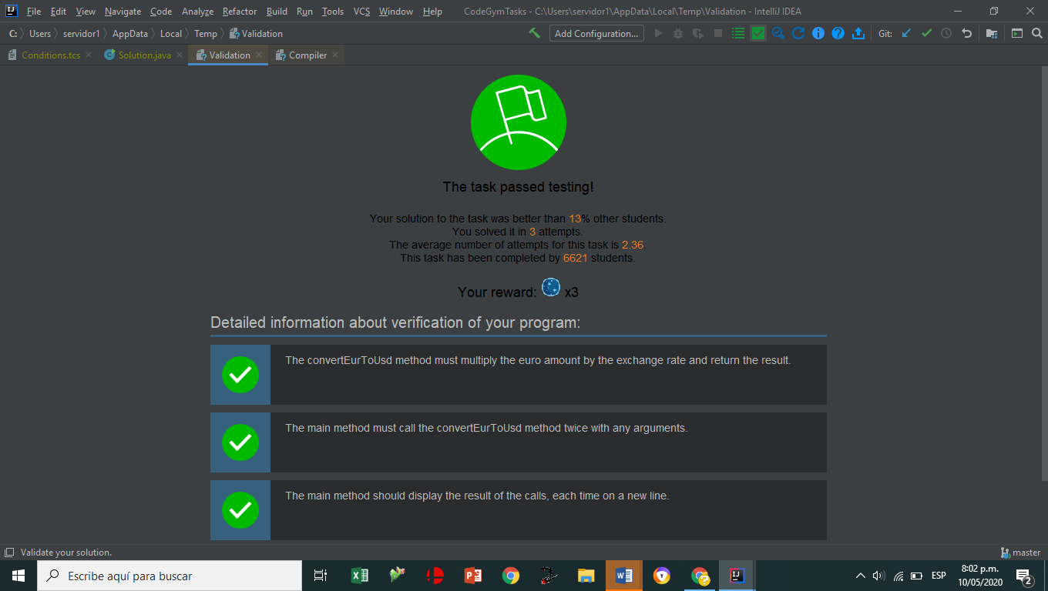

[N3_L3_E3](https://github.com/jaidernperez/Introduction_Programing/blob/master/CodeGym/N3_L3_E3.PNG)

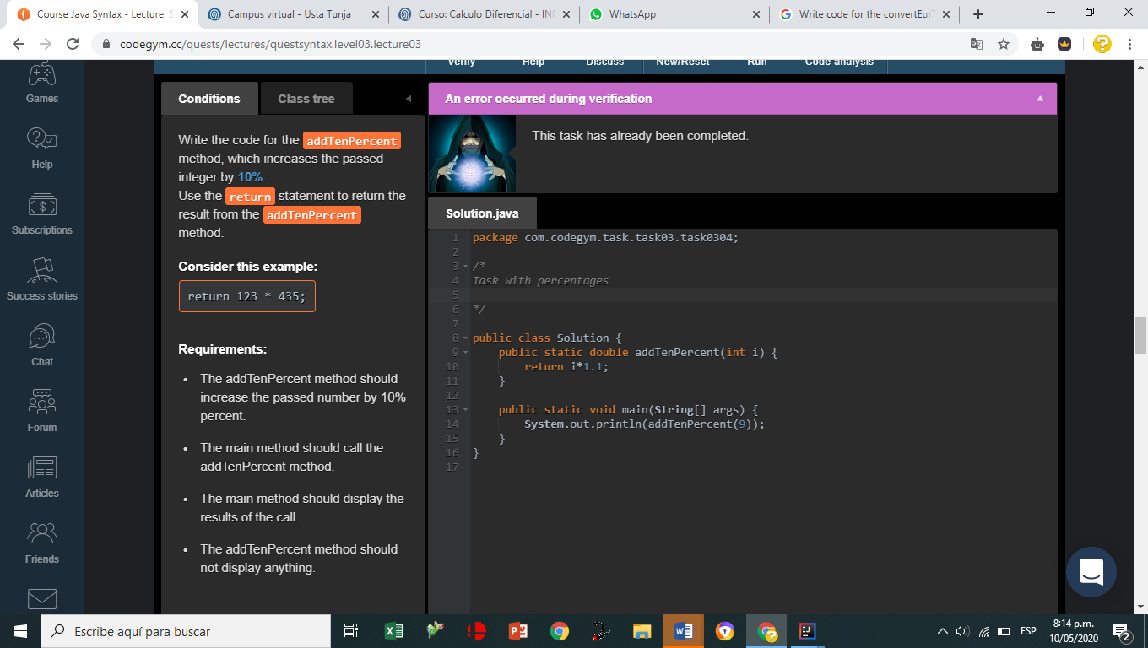

[N3_L4_E1](https://github.com/jaidernperez/Introduction_Programing/blob/master/CodeGym/N3_L4_E1.PNG)

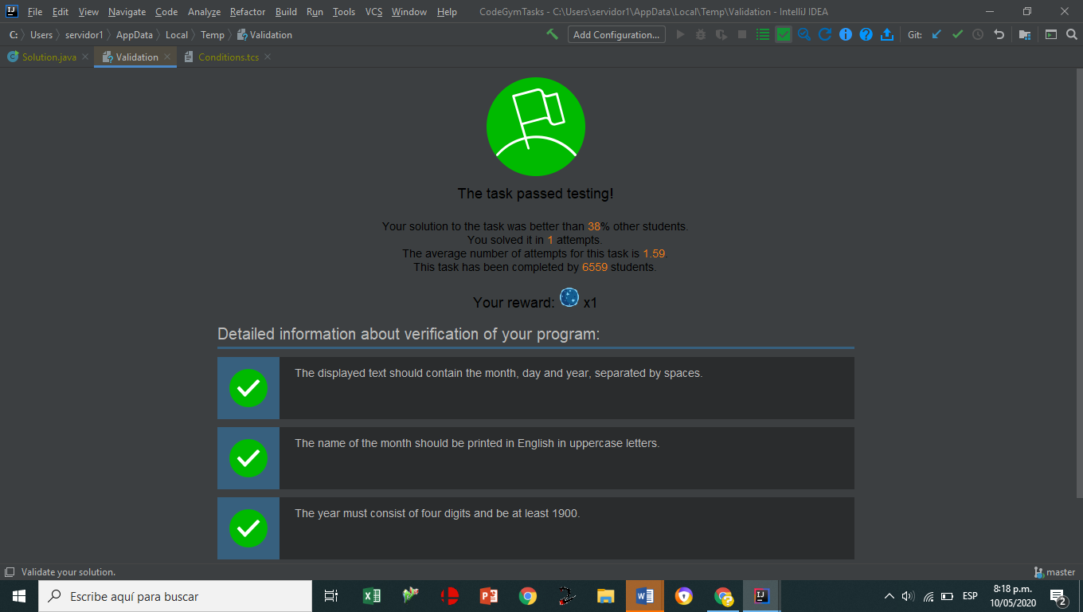

[N3_L4_E2](https://github.com/jaidernperez/Introduction_Programing/blob/master/CodeGym/N3_L4_E2.PNG)

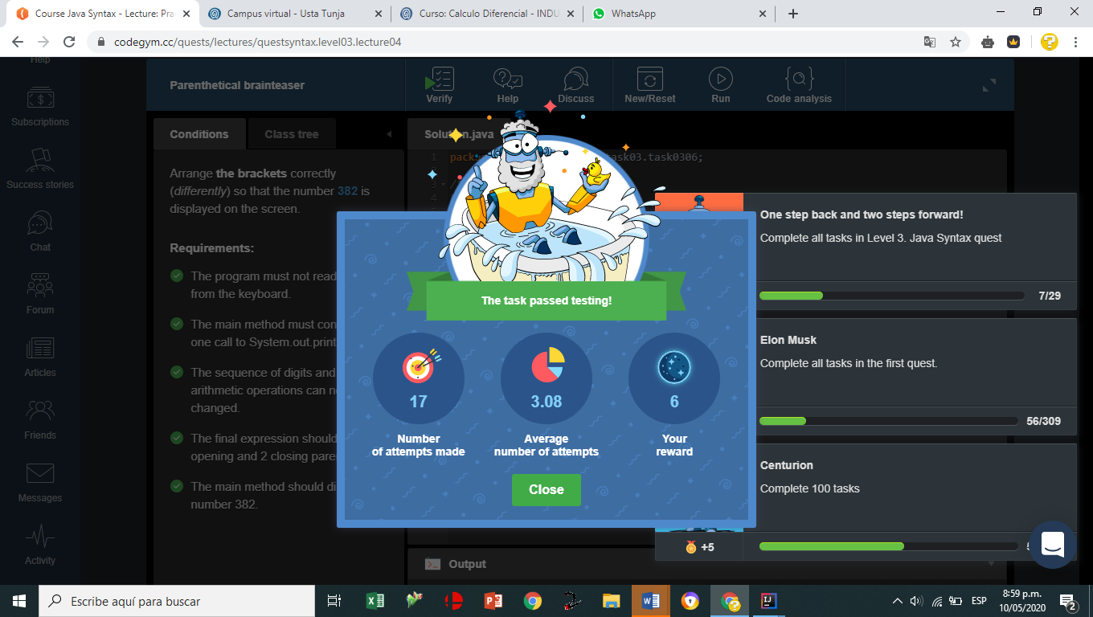

[N3_L4_E3](https://github.com/jaidernperez/Introduction_Programing/blob/master/CodeGym/N3_L4_E3.PNG)

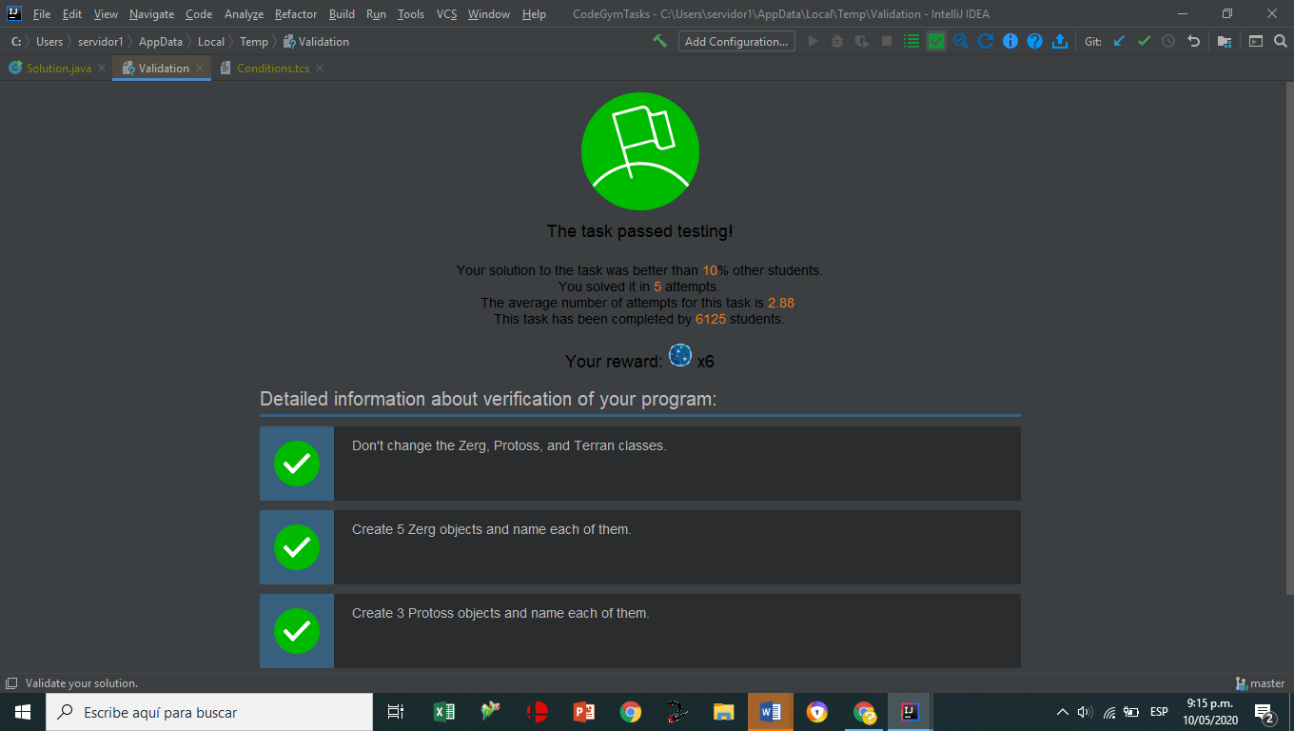

[N3_L4_E4](https://github.com/jaidernperez/Introduction_Programing/blob/master/CodeGym/N3_L4_E4.PNG)

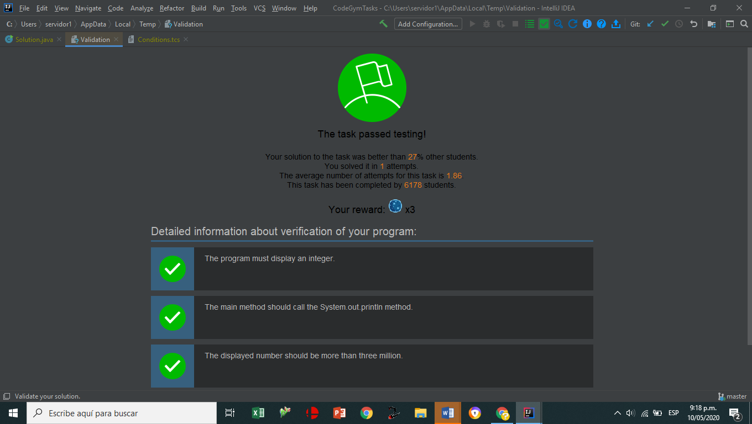

[N3_L4_E5](https://github.com/jaidernperez/Introduction_Programing/blob/master/CodeGym/N3_L4_E5.PNG)

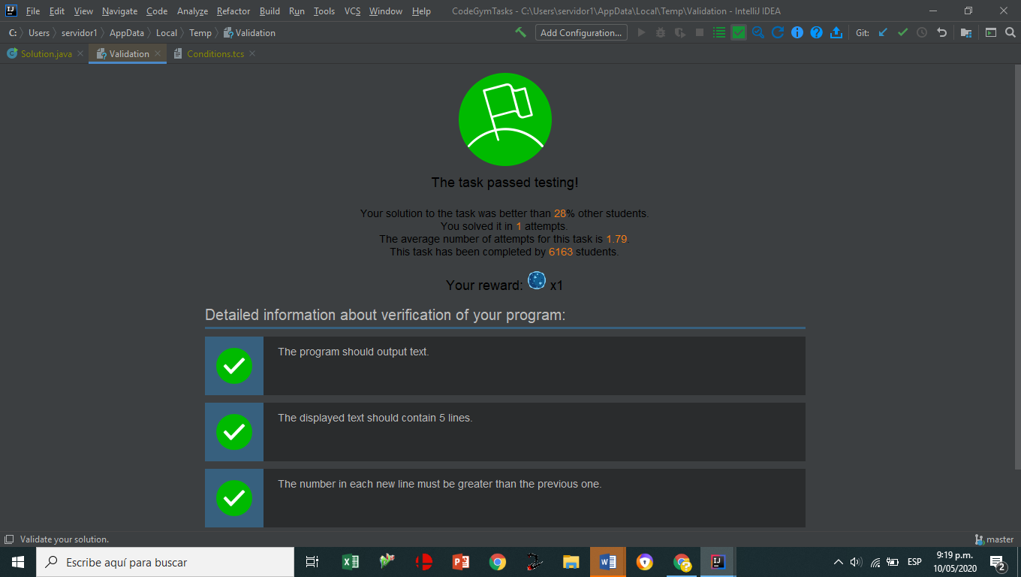

[N3_L5_E1](https://github.com/jaidernperez/Introduction_Programing/blob/master/CodeGym/N3_L5_E1.PNG)

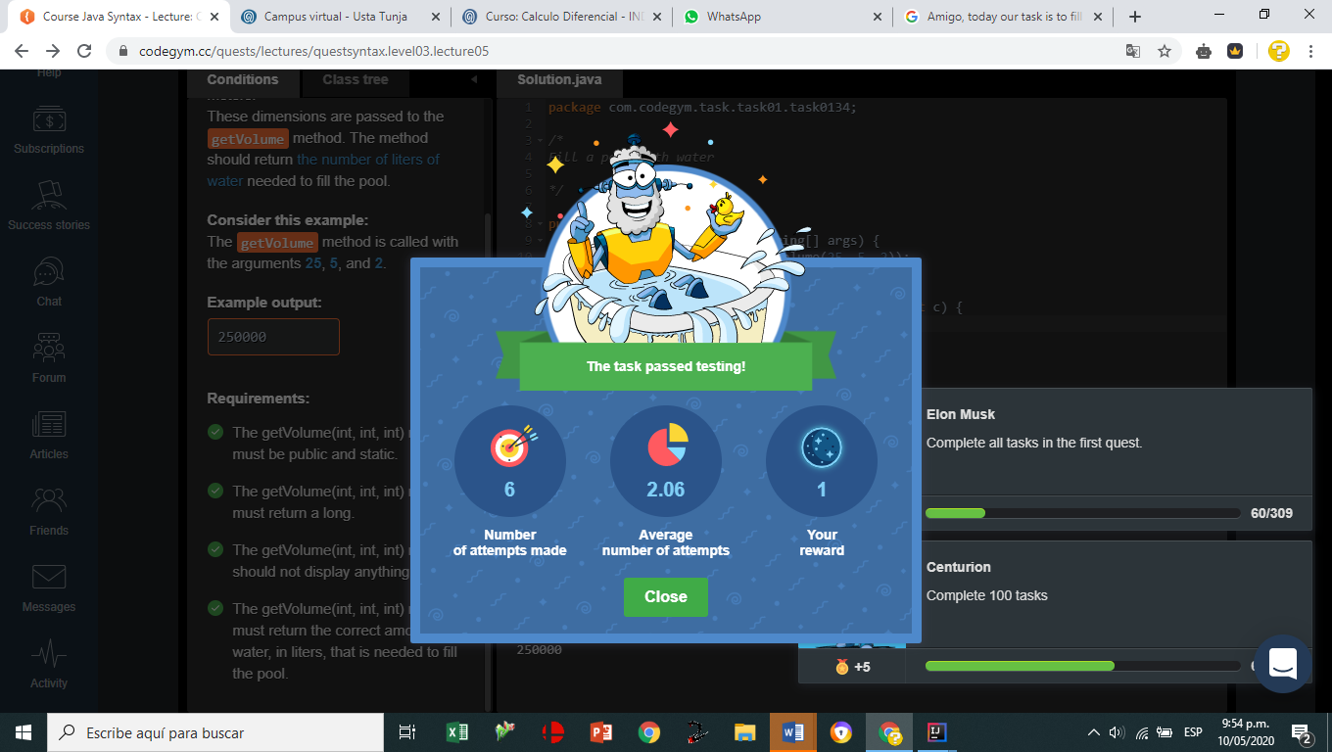

[N3_L5_E2](https://github.com/jaidernperez/Introduction_Programing/blob/master/CodeGym/N3_L5_E2.PNG)

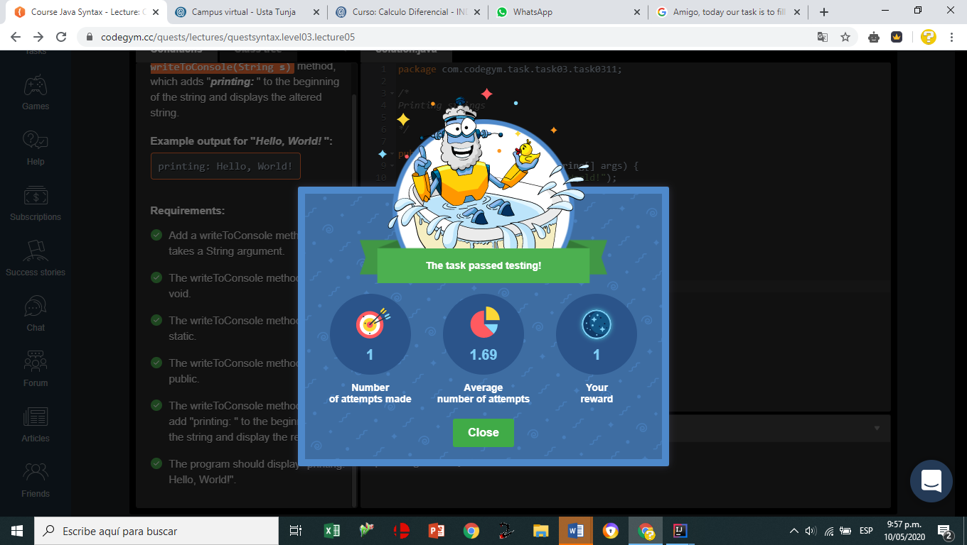

[N3_L5_E3](https://github.com/jaidernperez/Introduction_Programing/blob/master/CodeGym/N3_L5_E3.PNG)

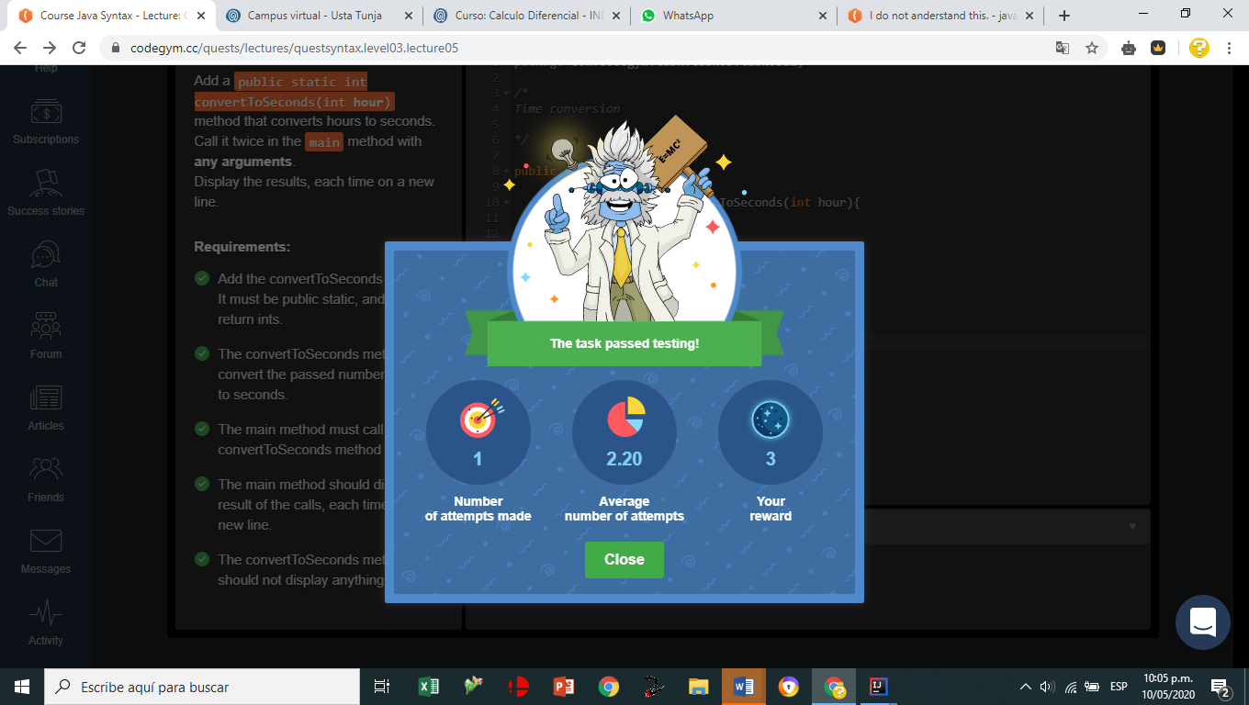

[N3_L6_E1](https://github.com/jaidernperez/Introduction_Programing/blob/master/CodeGym/N3_L6_E1.PNG)

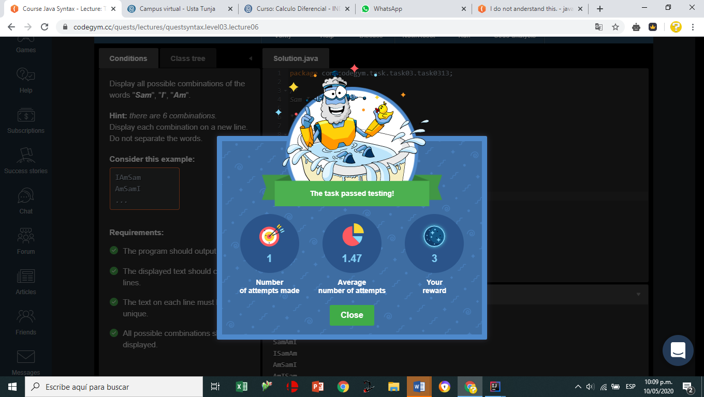

[N3_L6_E2](https://github.com/jaidernperez/Introduction_Programing/blob/master/CodeGym/N3_L6_E2.PNG)

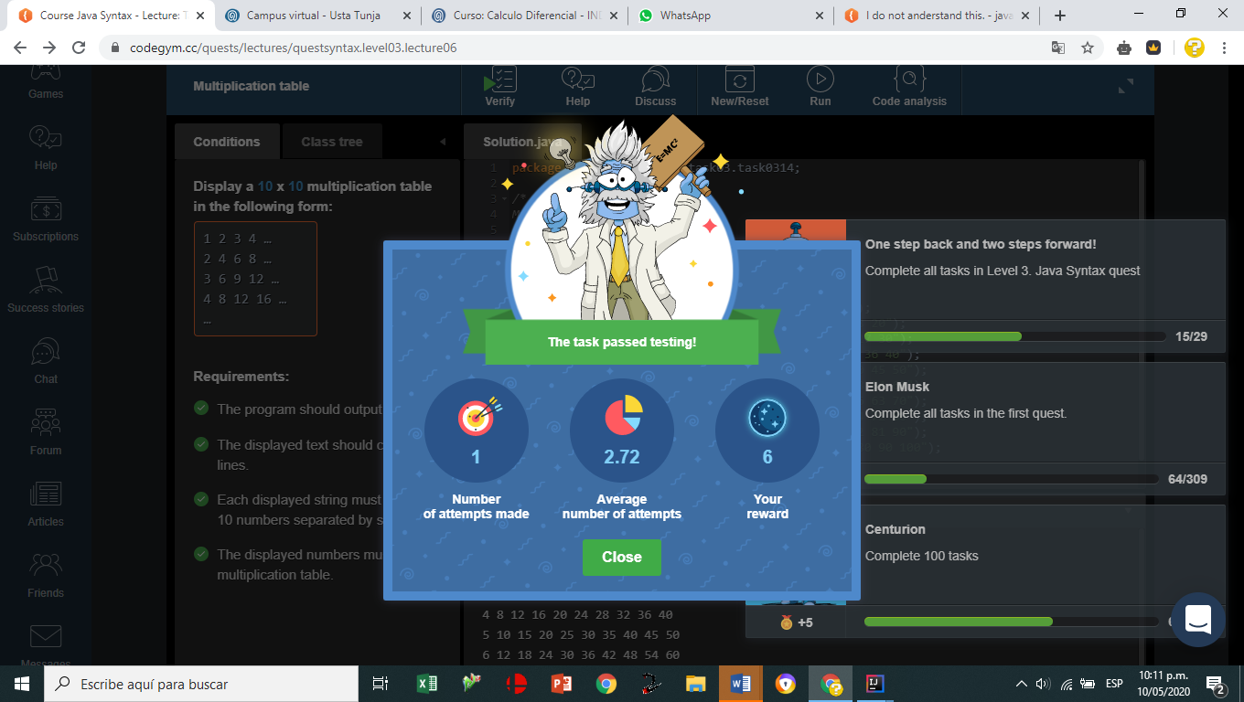

[N3_L6_E3](https://github.com/jaidernperez/Introduction_Programing/blob/master/CodeGym/N3_L6_E3.PNG)

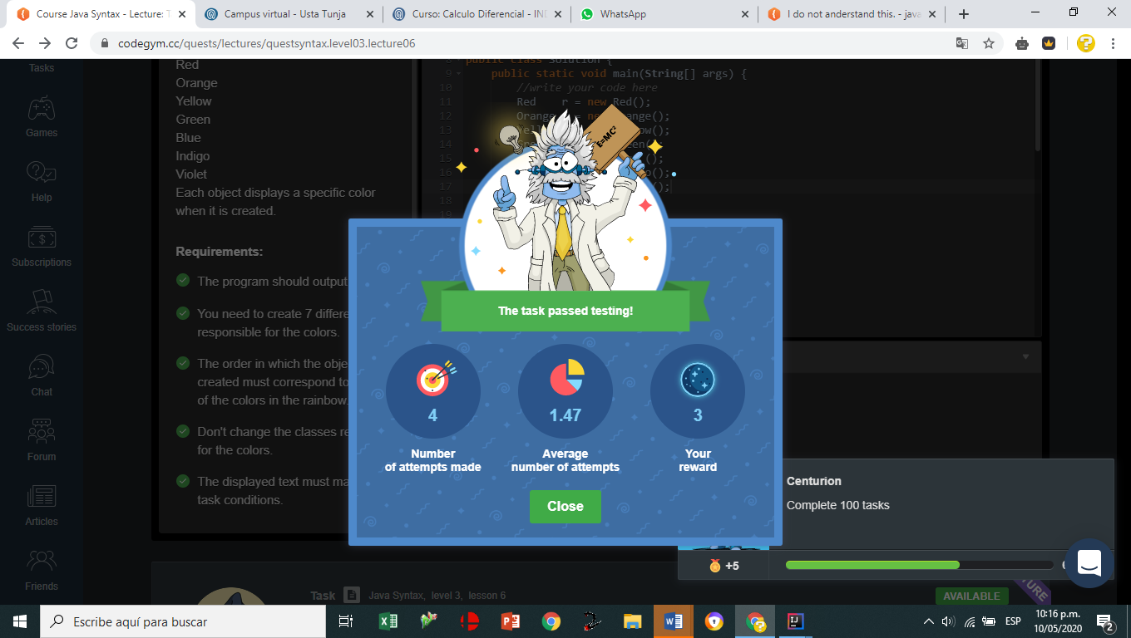

[N3_L6_E4](https://github.com/jaidernperez/Introduction_Programing/blob/master/CodeGym/N3_L6_E4.PNG)

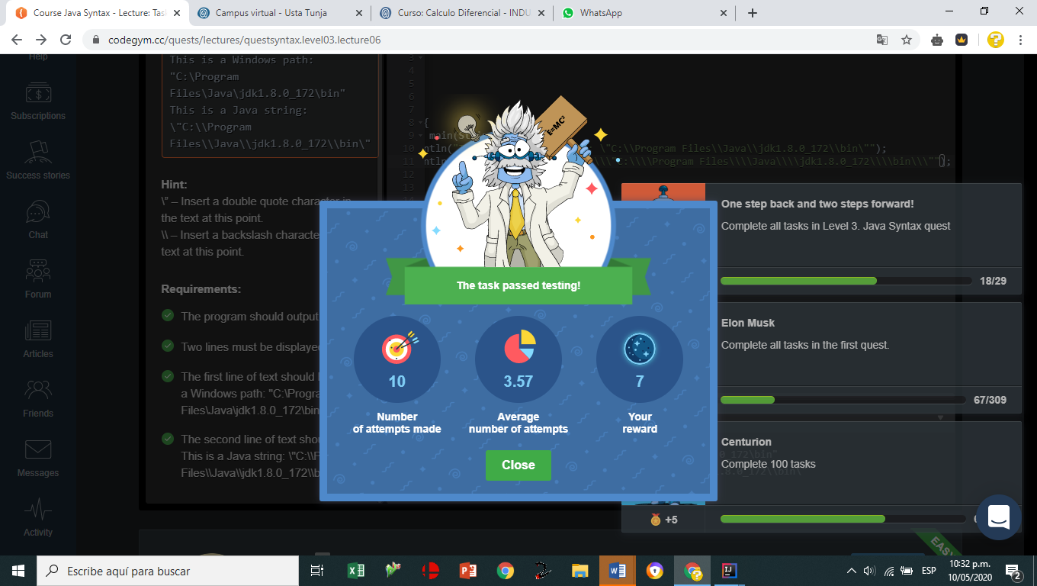

[N3_L6_E5](https://github.com/jaidernperez/Introduction_Programing/blob/master/CodeGym/N3_L6_E5.PNG)

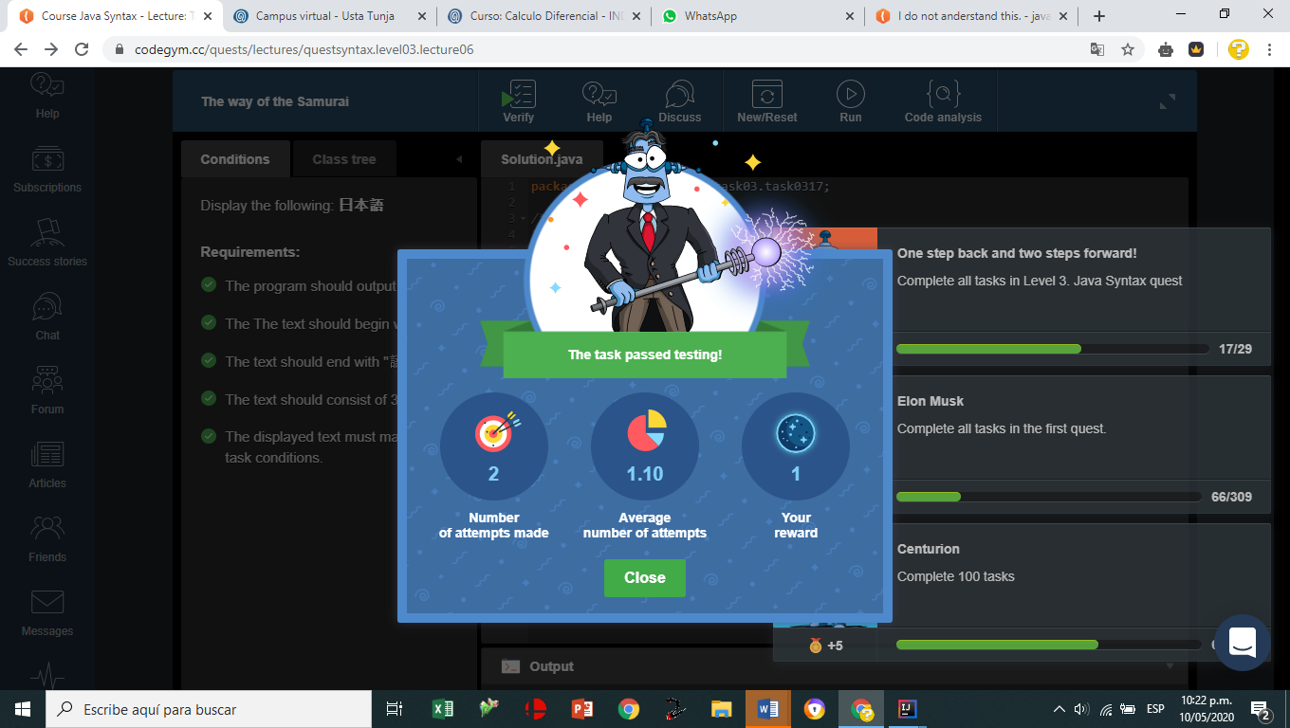

[N3_L8_E1](https://github.com/jaidernperez/Introduction_Programing/blob/master/CodeGym/N3_L8_E1.PNG)

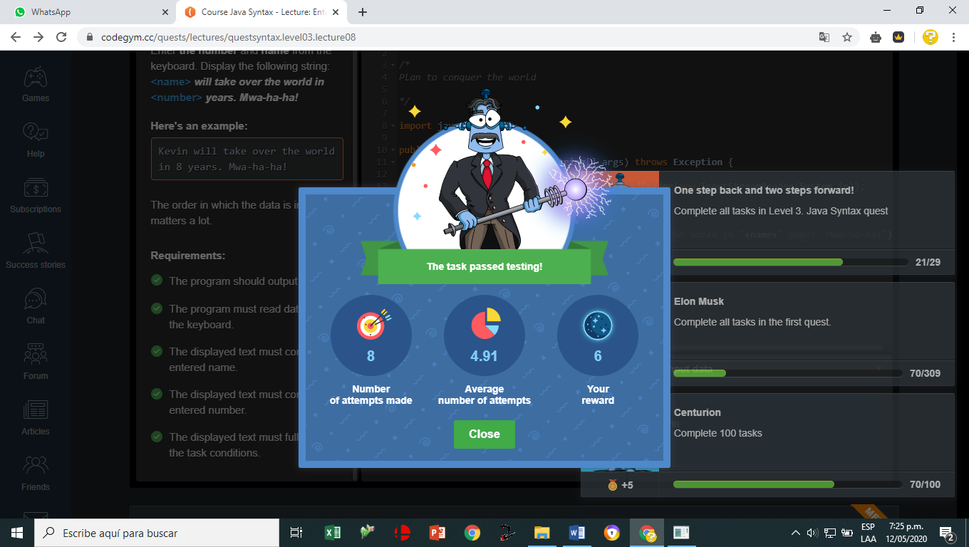

[N3_L8_E2](https://github.com/jaidernperez/Introduction_Programing/blob/master/CodeGym/N3_L8_E2.PNG)

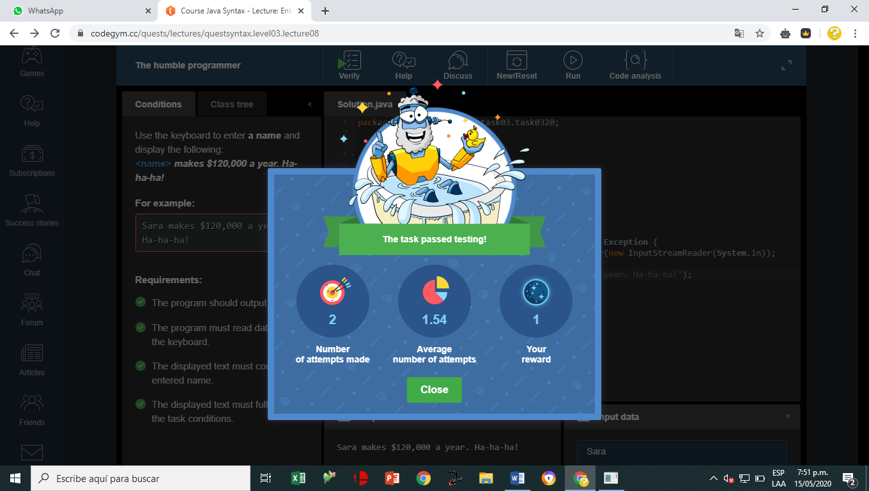

[N3_L8_E3](https://github.com/jaidernperez/Introduction_Programing/blob/master/CodeGym/N3_L8_E3.PNG)

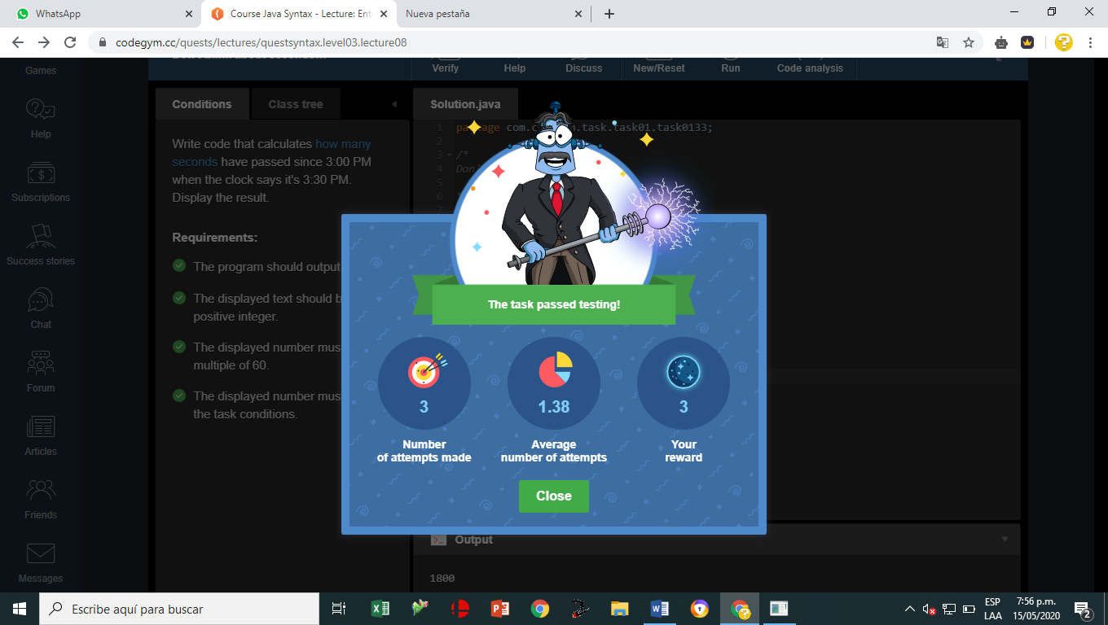

[N3_L8_E4](https://github.com/jaidernperez/Introduction_Programing/blob/master/CodeGym/N3_L8_E4.PNG)

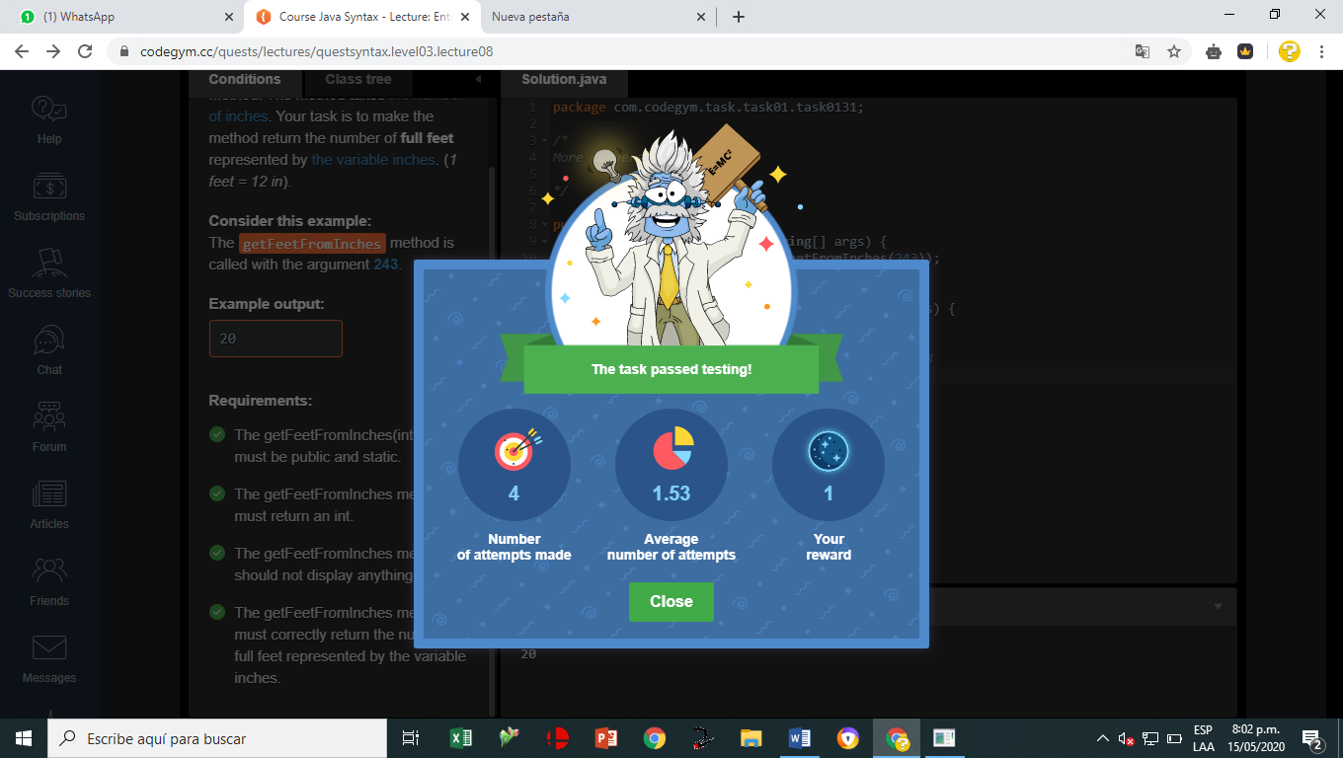

[N3_L8_E5](https://github.com/jaidernperez/Introduction_Programing/blob/master/CodeGym/N3_L8_E5.PNG)

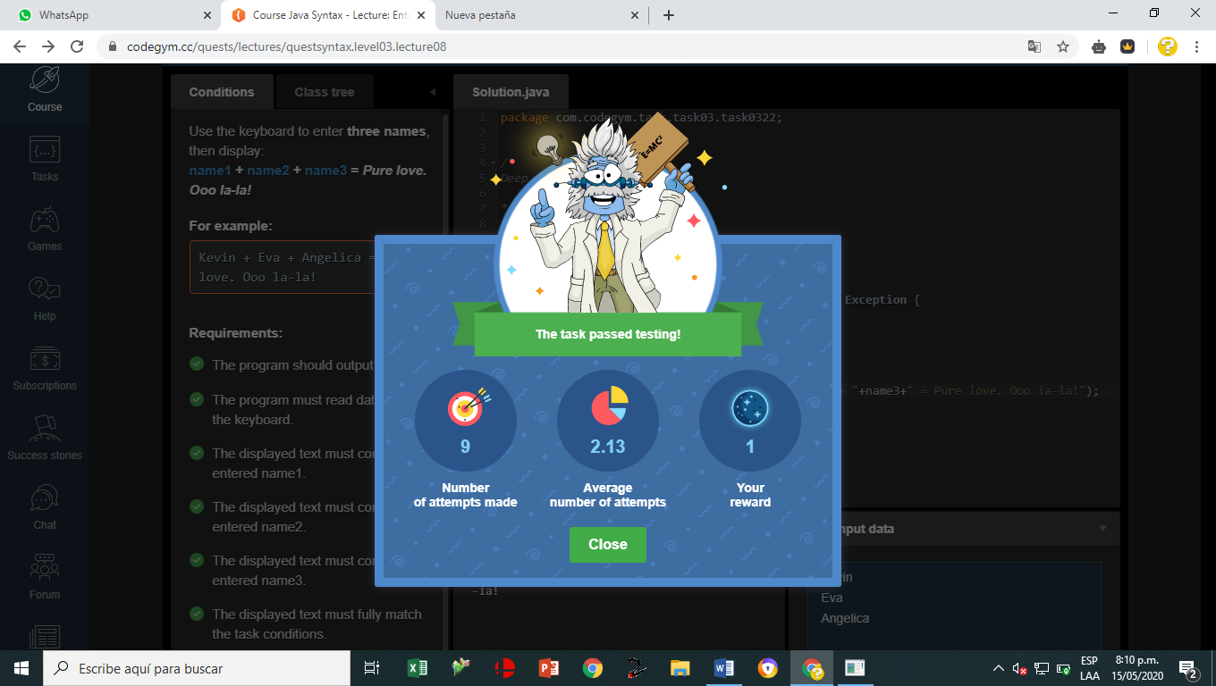

[N3_L8_E6](https://github.com/jaidernperez/Introduction_Programing/blob/master/CodeGym/N3_L8_E6.PNG)

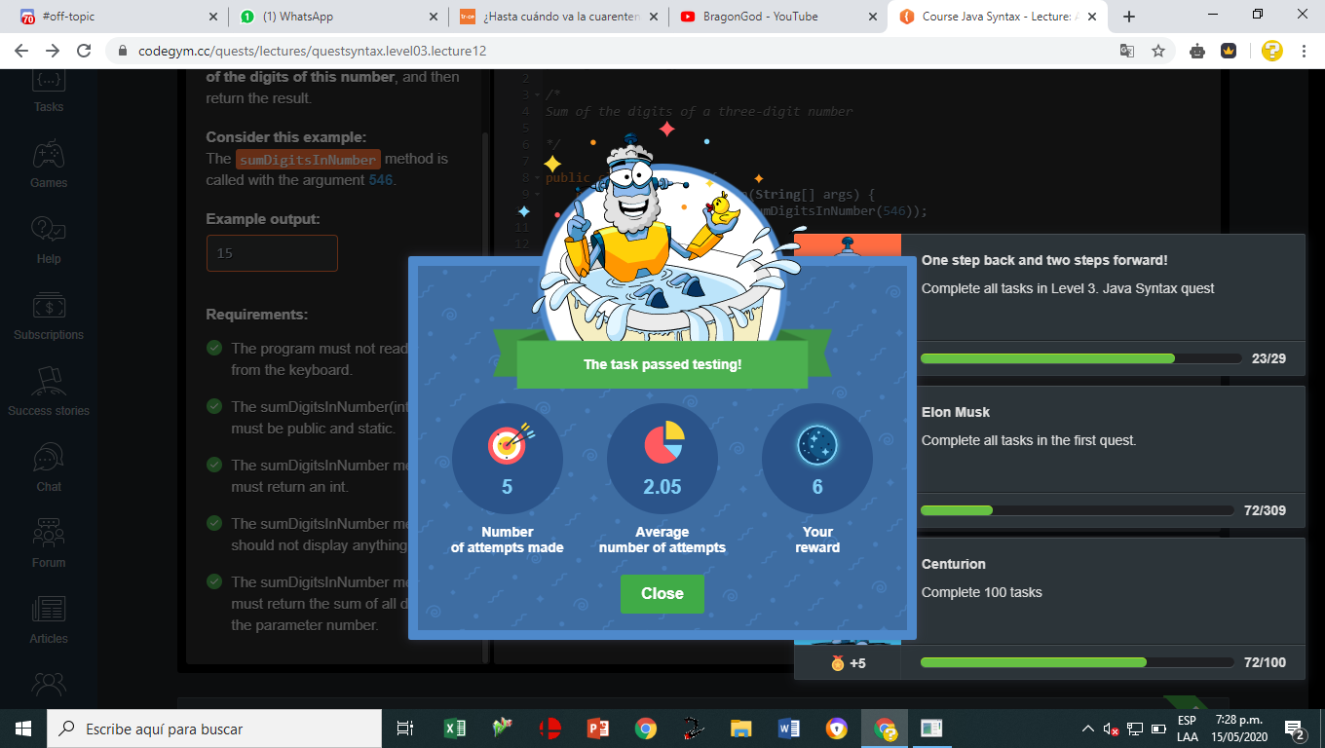

[N3_L12_E1](https://github.com/jaidernperez/Introduction_Programing/blob/master/CodeGym/N3_L12_E1.PNG)

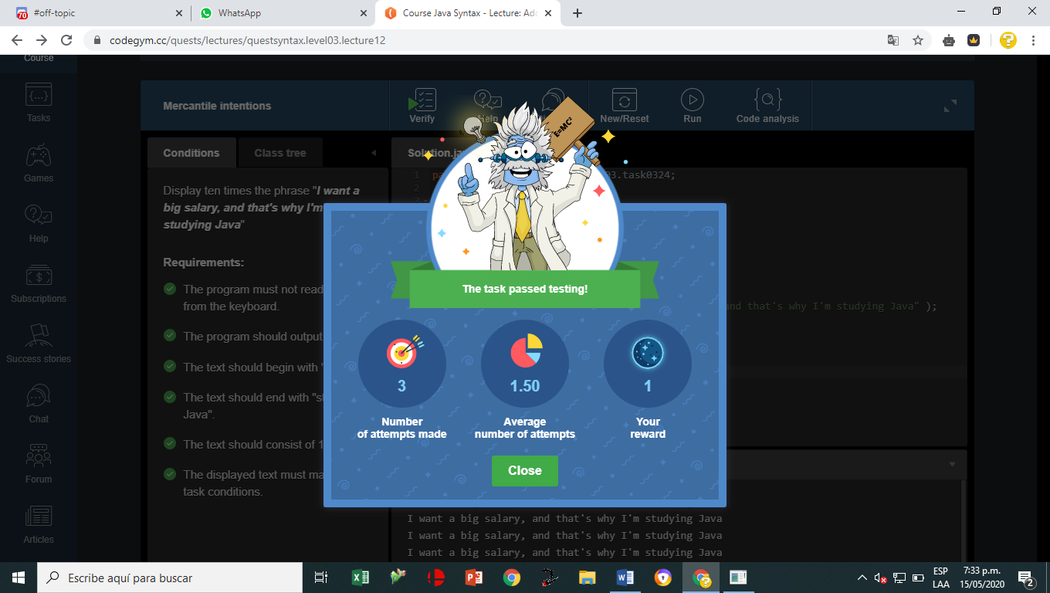

[N3_L12_E2](https://github.com/jaidernperez/Introduction_Programing/blob/master/CodeGym/N3_L12_E2.PNG)

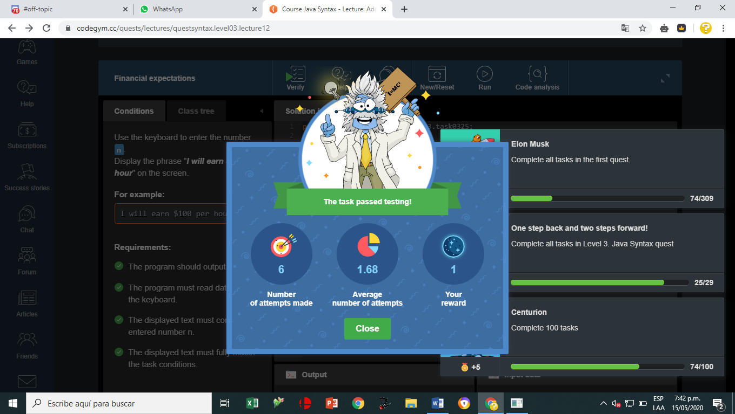

Logros

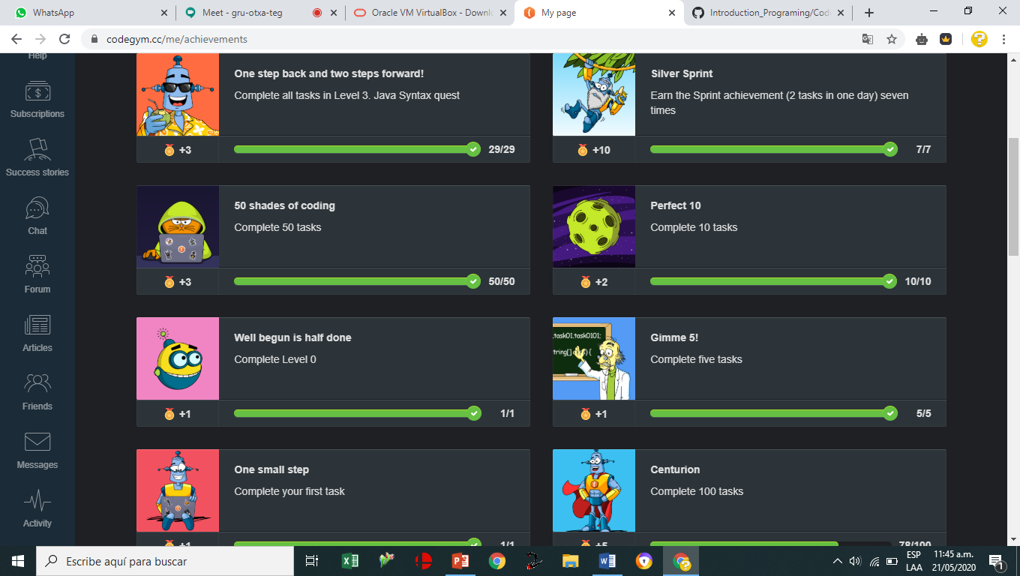

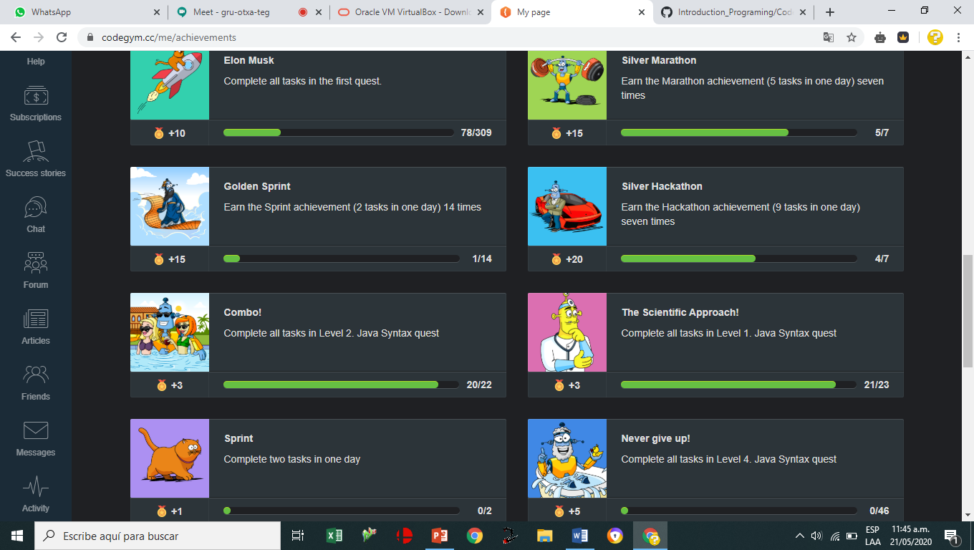

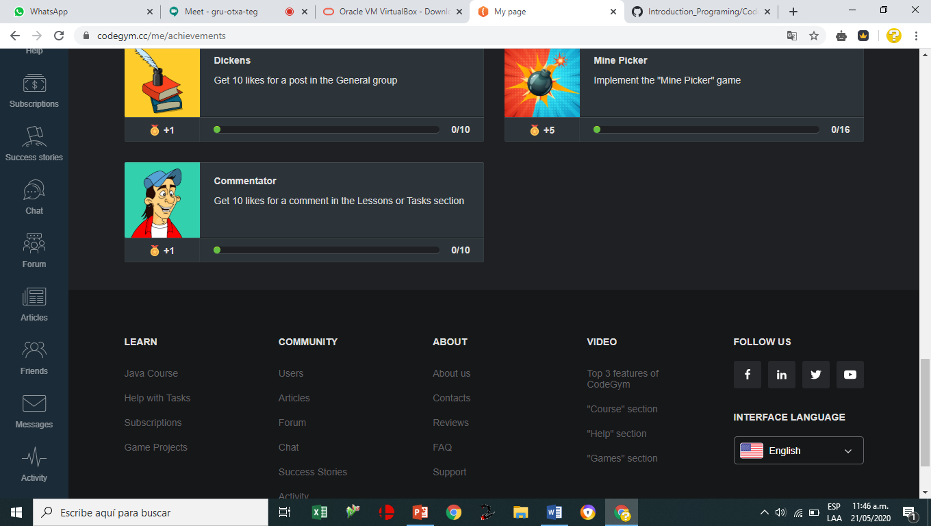

Materia oscura

